AURIKA
E-Commerce Product Information
Tagline: Where Art Meets Elegance

Product Category 1 — Hand-Poured Scented Candles
Product Name:
[Exact product name]
Category:
Scented Candles
Short Description:
[1–2 sentence description for product listing]
Fragrance:
[Fragrance name]
Wax Type:
Paraffin
Variants:
[Single variant / list available variants]
Size / Weight:
[Final measurement]
Price:
PKR [price]
Stock Quantity:
[quantity]
Burn Time:
[To be confirmed]
Candle Care:
[Care instructions]
Product Images
- Main product image: [filename]
- Front/side angle: [filename]
- Detail/close-up: [filename]
- Lifestyle image: [filename]
- Packaging image: [filename]

1.
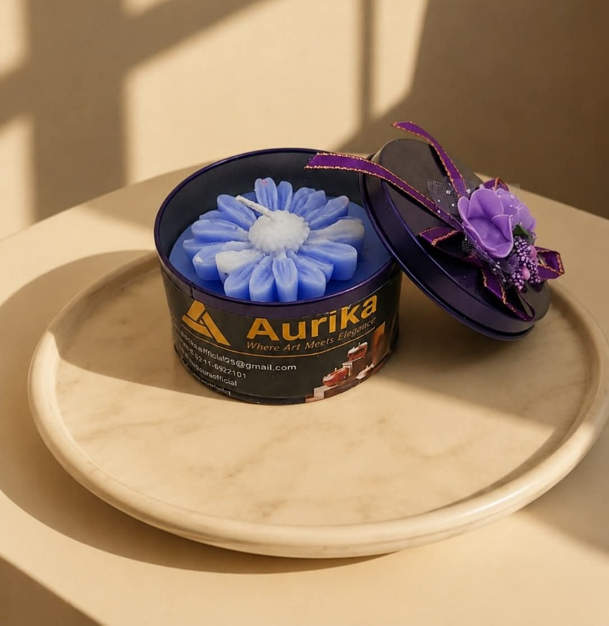
name: lavender scented candle, price : 999 , fragrance : lavender , variants: rose and sunflower ,lavender scented candles ,burning time: 24 hours .
Description:
A beautifully crafted scented candle with a soothing lavender fragrance, designed to add warmth and elegance to your space.

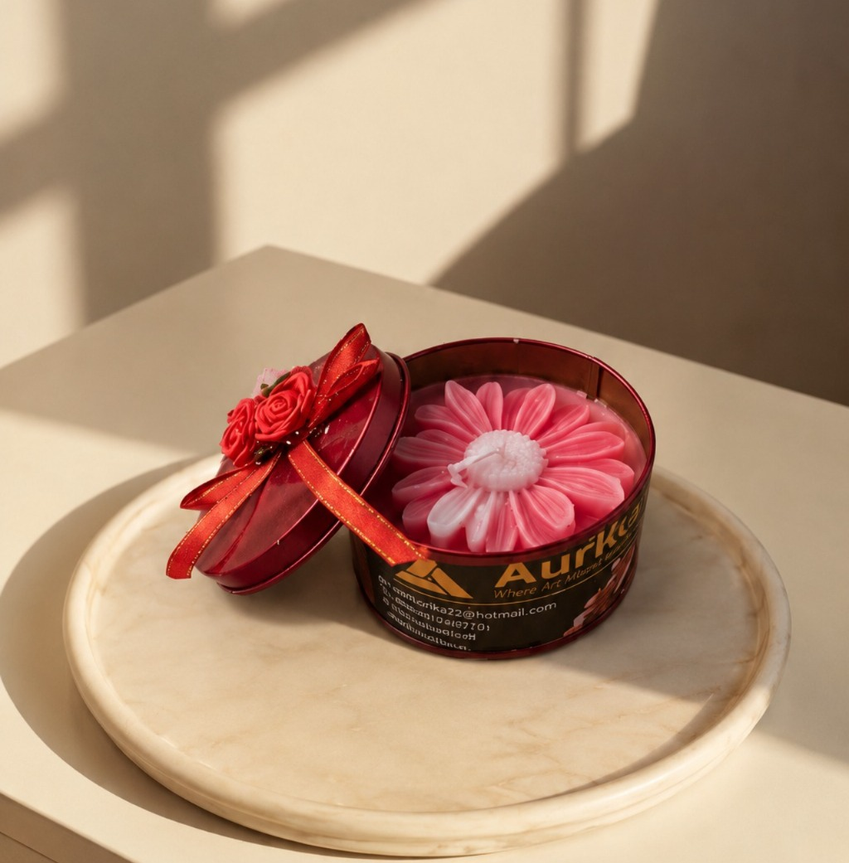
Fragrance :Rose

2.
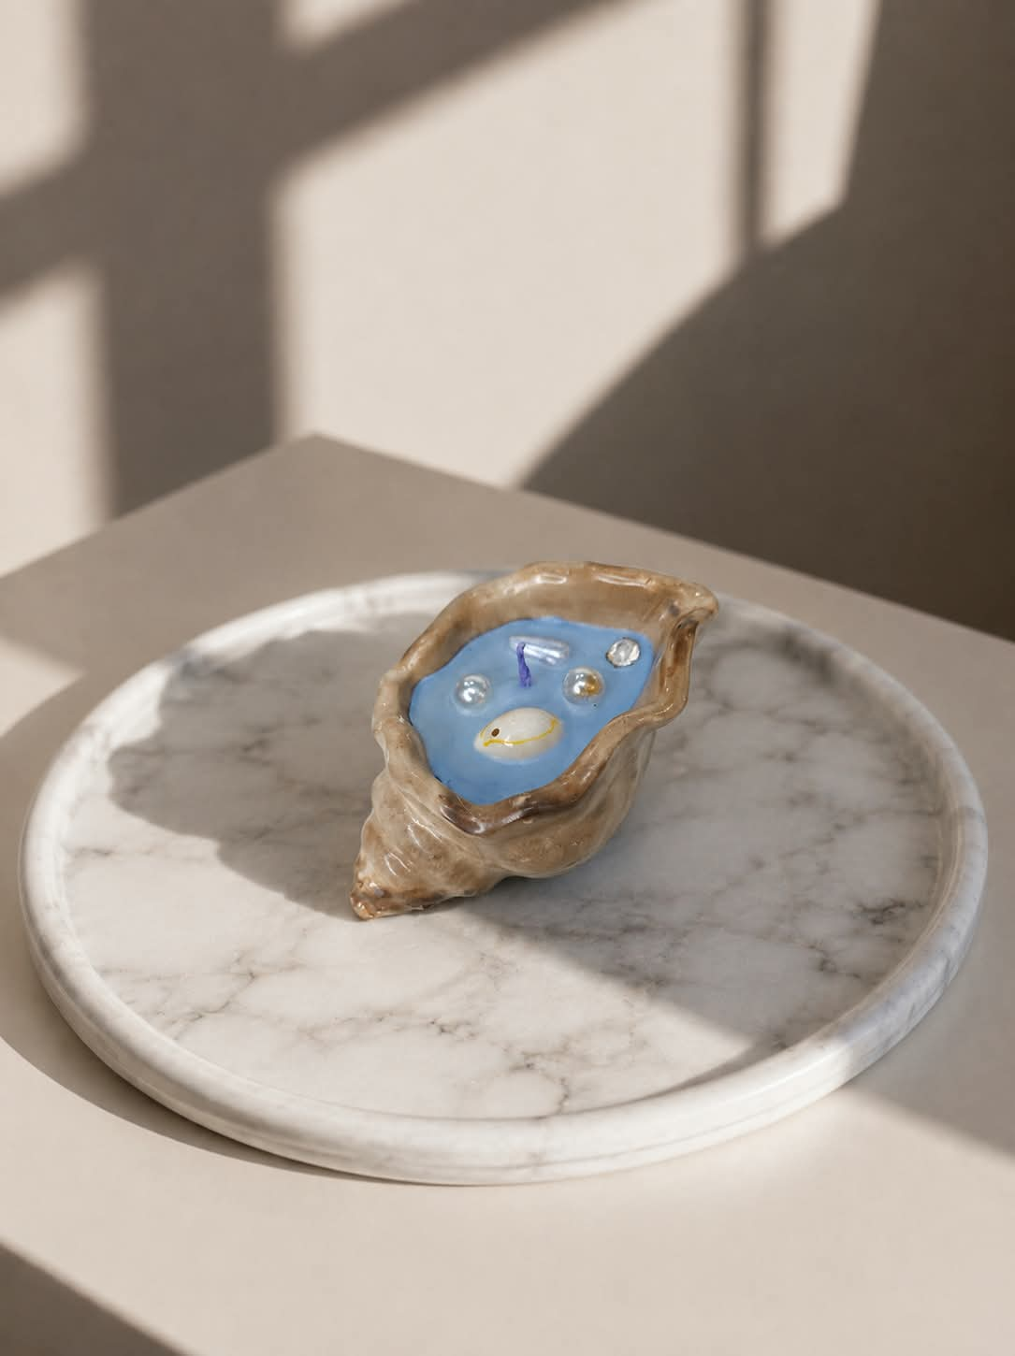

name: sea shell ocean candle , price : 699, fragrance : ocean , variants: sea shell ocean candle, burning time: 10 hours
Description:
A sea-shell inspired candle with a refreshing ocean fragrance, bringing a coastal touch to your space.
3.
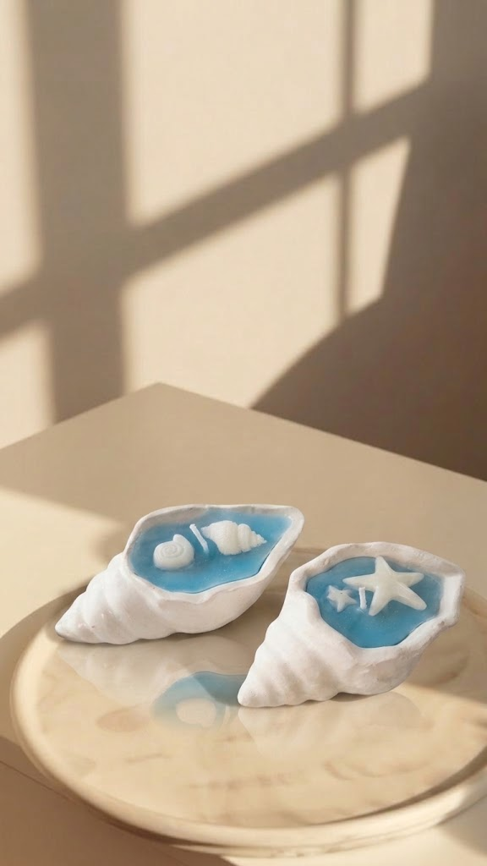
name: sea shell ocean candle , price : 599 ( 1 peice) ,1100 (2 peice), fragrance : ocean , variants: sea shell ocean candle,burning time: 10 hours.
Description:
A charming sea-shell candle with a refreshing ocean fragrance, perfect for adding a decorative touch to your space.

4.
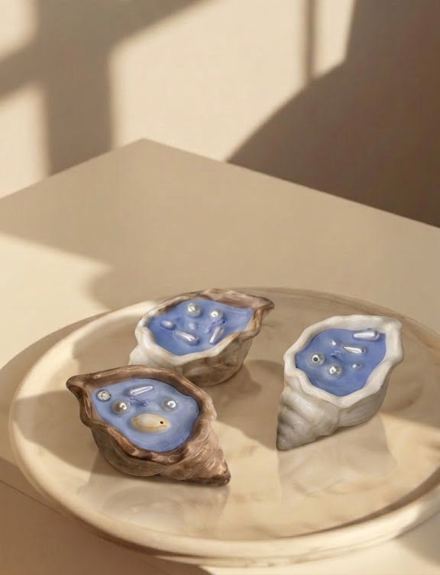
name: sea shell ocean candle , price : 1799 , fragrance : ocean , variants: sea shell ocean candle,burning time: 10 hours (individual).
Description:
An artistic sea-shell candle with a refreshing ocean fragrance, designed to combine decorative appeal with a fragrant experience.

5.

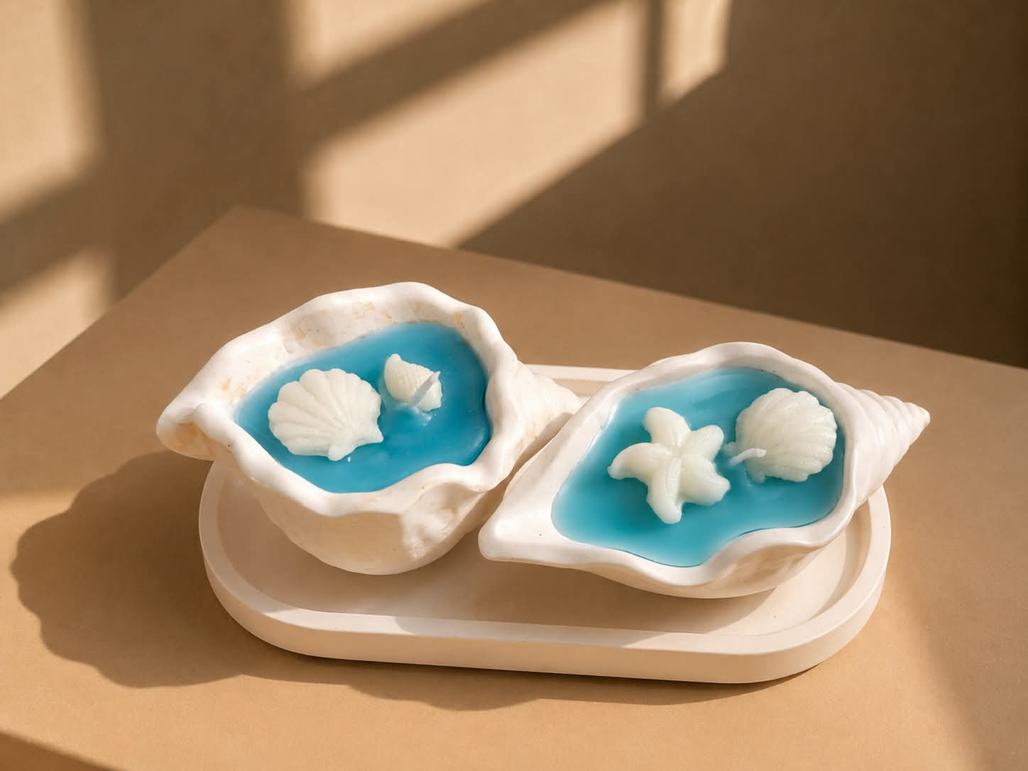
name: sea shell ocean candle (2 pieces with tray) , price : 1499 , fragrance : ocean ,2 variants: sea shell ocean candle,burning time: 10 hours (individual)
Description:
A two-piece sea-shell candle set with a tray and refreshing ocean fragrance, perfect for gifting or elegant home décor.

6.
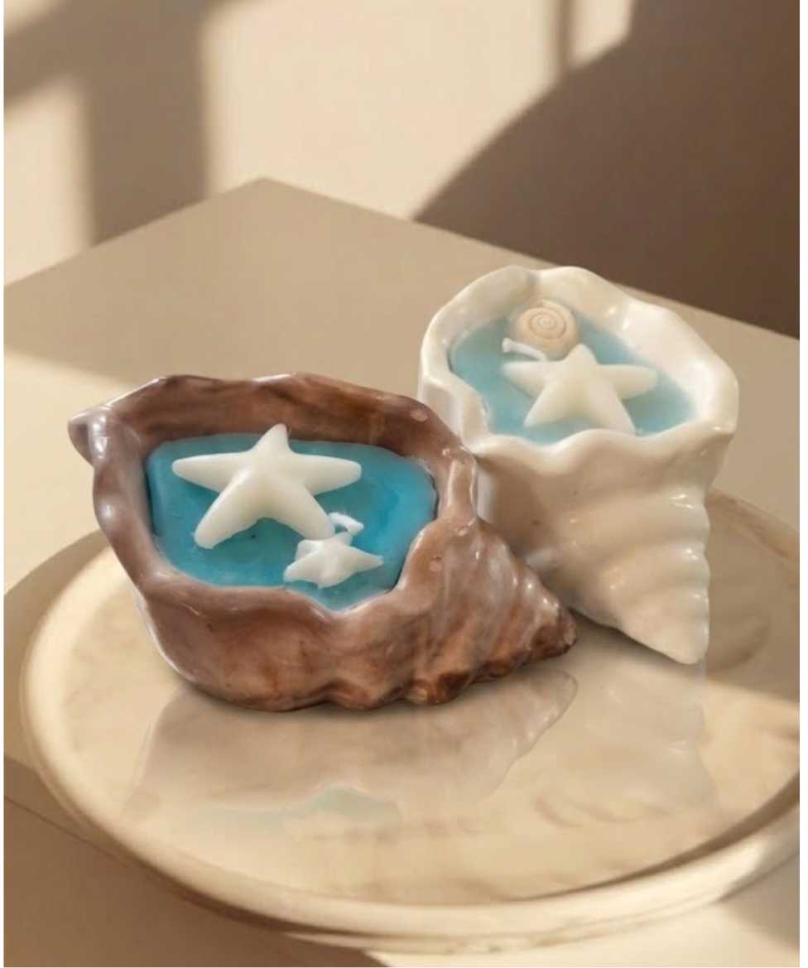

name: sea shell ocean candle , price : 1299 (2 pieces) , fragrance : ocean , variants: sea shell ocean candle,burning time: 10 hours (individual)
Description:
A set of two artistic sea-shell candles with a refreshing ocean fragrance, adding charm and warmth to your space.
7.
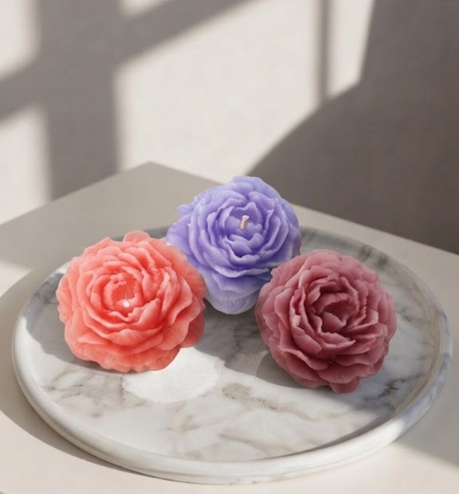
name: peony flower scented candle , price : 199 (1 peice) ,499(3 peice) , fragrance/variants : lavender, rose,lily ,burning time: 6 hours (individual)
Description:
A delicate peony flower-shaped candle available in lavender, rose, and lily fragrances, perfect for adding a floral touch to your space.

8.

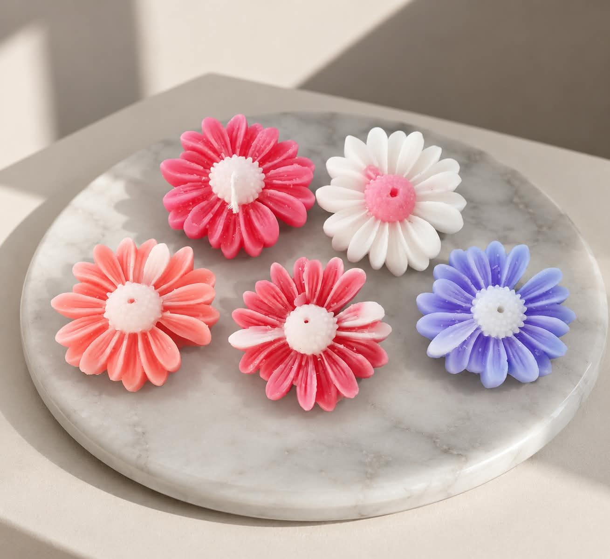
name: daisy flower candle , price : 150(1 peice) 399(3 peice), fragrance /ariants: rose,lily,lavender ,sunflower, burning time: 5 hours (individual)
Description:
A charming daisy-shaped candle available in rose, lily, lavender, and sunflower fragrances.

9.
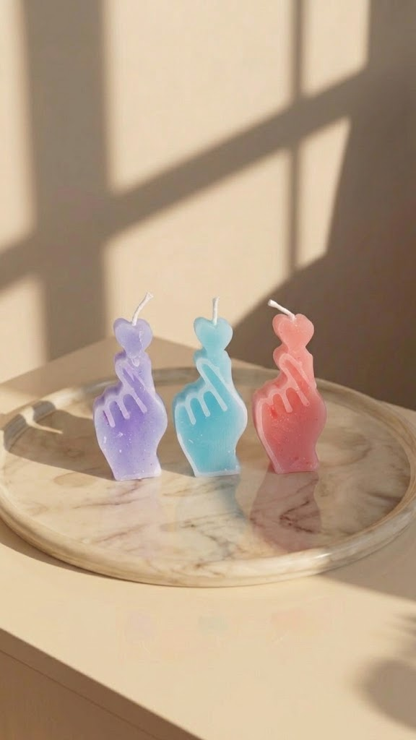
name: mini heart hand candles , price : 80(1 peice) 250(3 peice) 150(2 peices), fragrance /variants: rose,ocean,lavender ,burning time: 5 hours (individual)
Description:
Small heart-shaped candles available in rose, ocean, and lavender fragrances—perfect for gifting and adding a decorative touch to your space.
10.
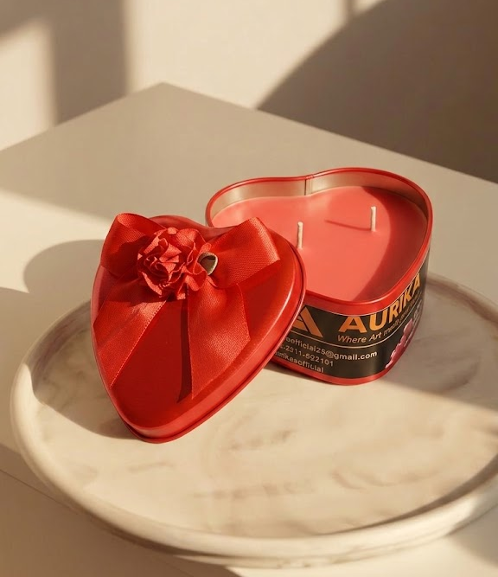
name: Aurika rose heart candle, price : 999 (1 peice) , fragrance /variants: rose ,burning time: 15 hours
Description:
An elegant heart-shaped candle with a beautiful rose fragrance, designed to add warmth, charm, and elegance to your space.
11.
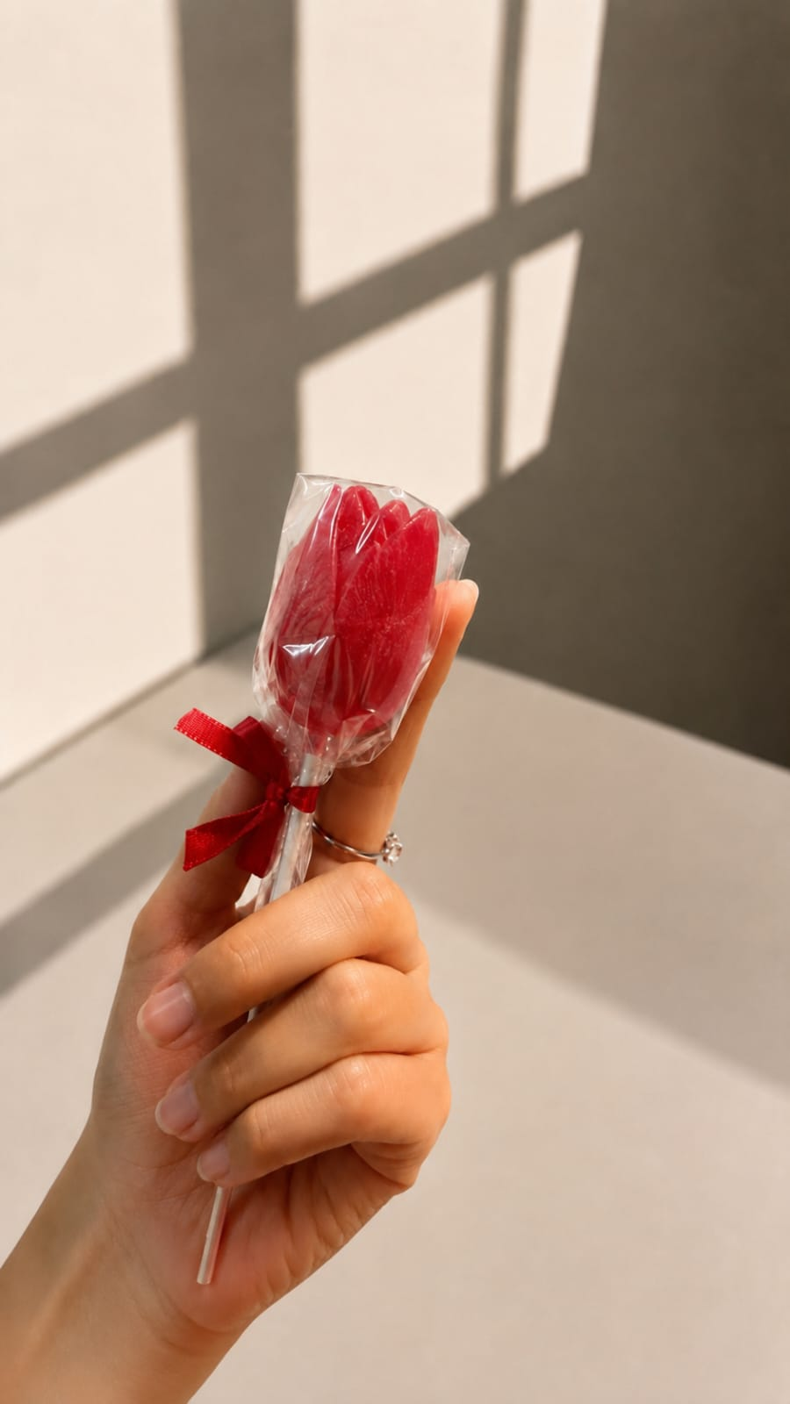
name: rose flower price : 299 , fragrance/variants: rose scented candles ,burning time: 5 hours.
Description:
A decorative rose-shaped candle with a delicate rose fragrance, bringing a floral and elegant touch to your space.

12.
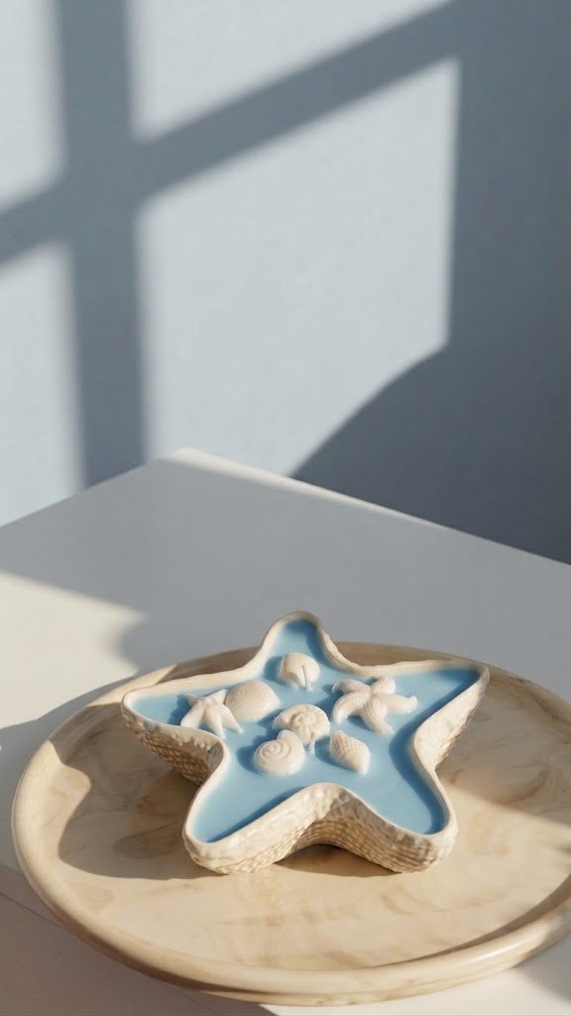
name: star fish scented candle , price : 1199 (1 peice) fragrance /variants: ocean ,burning time: 8 hours (individual)
Description:
An artistic starfish-shaped candle with a refreshing ocean fragrance, inspired by the beauty of the sea.

Product Category 2 — DIY Art Kits for Children
Product 01
Product Name:
[Exact product name]
Category:
DIY Art Kits for Children
Short Description:
[1–2 sentence description]
Full Description:
[Detailed description]
What's Included:
- [Item]
- [Item]
- [Item]
- [Item]
Recommended Age:
3 to 12 years
Activity Type:
[Painting]
Size / Dimensions:
[Measurement]
Price:
PKR [price]
Stock Quantity:
[quantity]
Estimated Activity Time:
[Time, if finalized]
Safety Information:
[Relevant information]
Product Images
- Main product image: [filename]
- Contents of kit: [filename]
- In-use image: [filename]
- Finished artwork: [filename]
- Packaging: [filename]
1.
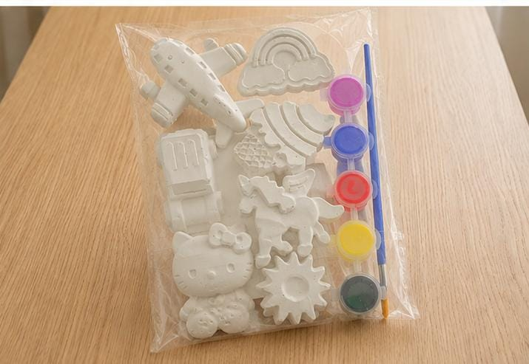

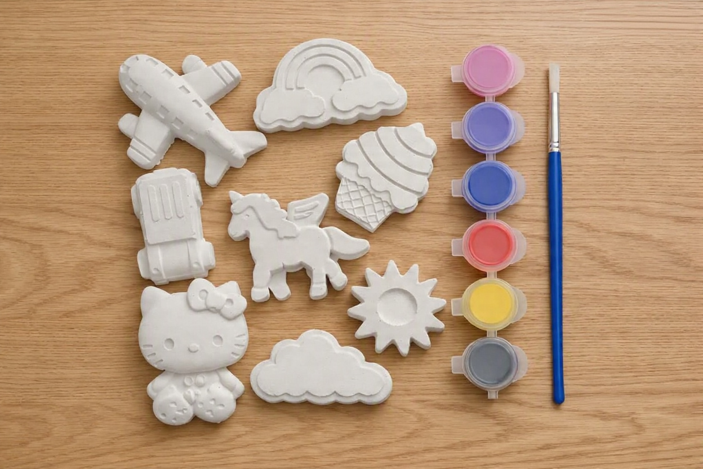

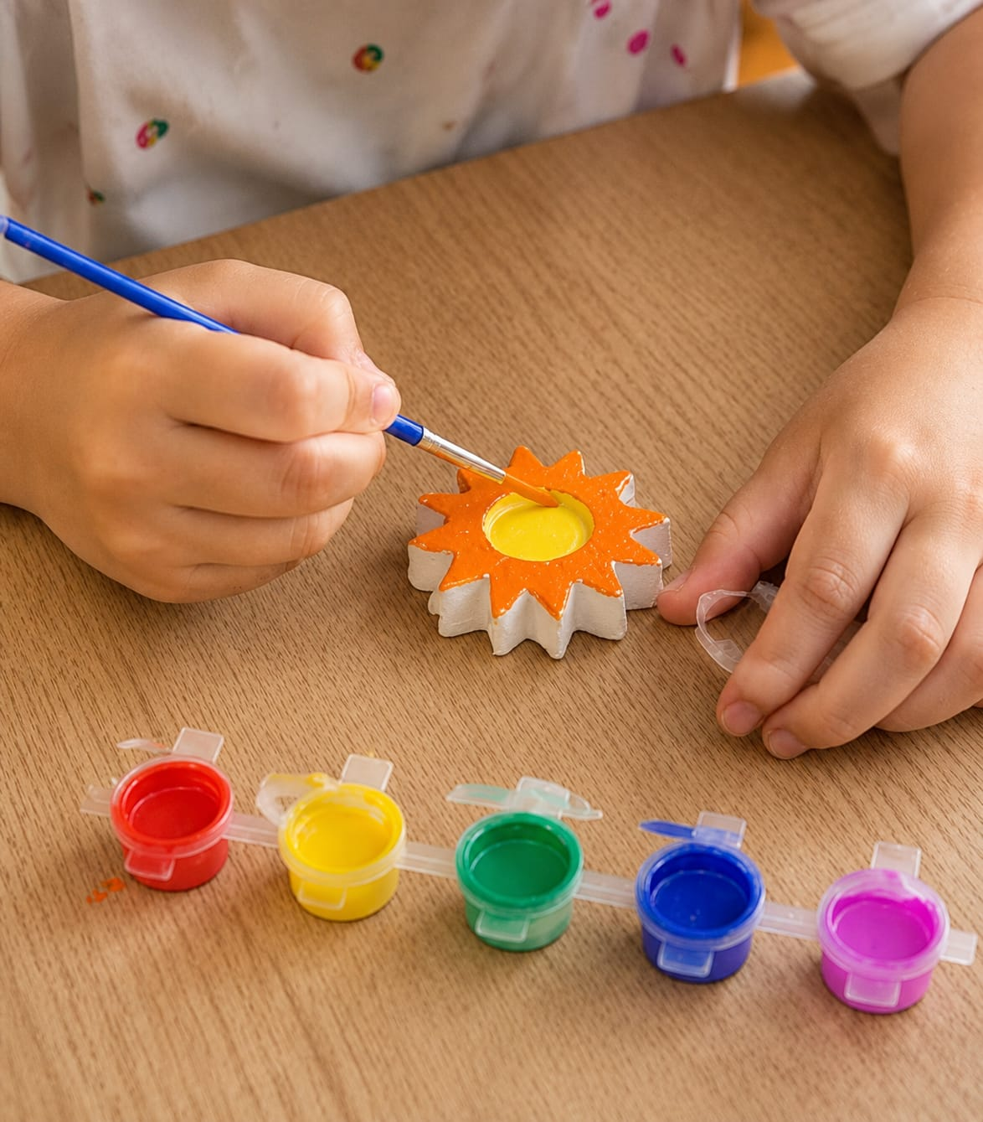

name: Diy art kit , price; 599 , item; painting brush,8 concrete toys ,painting colors , age: 3-12 .
Description:
A creative DIY painting kit with 8 concrete toys, paints, and a brush, designed to encourage hands-on creativity and imaginative play for children ages 3–12.

2.
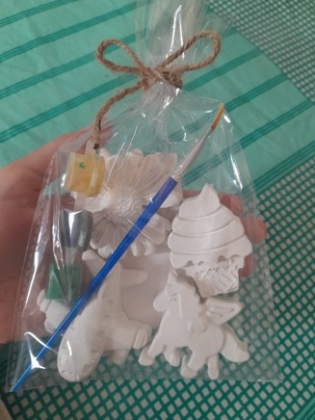
name: Diy art kit ,price; 299 , item; painting brush, 4 concrete toys ,painting colors , age: 3-12 .
Description:
A compact DIY painting kit with 4 concrete toys, paints, and a brush, designed for creative, hands-on fun for children ages 3–12.

